How To: Use the WordNorms.com Database

URL: <https://doomlab.shinyapps.io/double_words/>

What is it?

The Word norms database can help you to find pair of words to use for the related words condition.

How to Search WordNorms.com

1. Prior to doing the steps below, you should have searched the MRC database for words using the parameters that you want for your study (e.g. concreteness/imageability)
2. **Go to** <http://www.cogsci.mq.edu.au/research/resources/nwdb/nwdb.html>
3. Scroll down to the **View and Search Similarity Data** section. Using the list of words you have obtained from the MRC database, select one word and type it in to the **Cue** box.

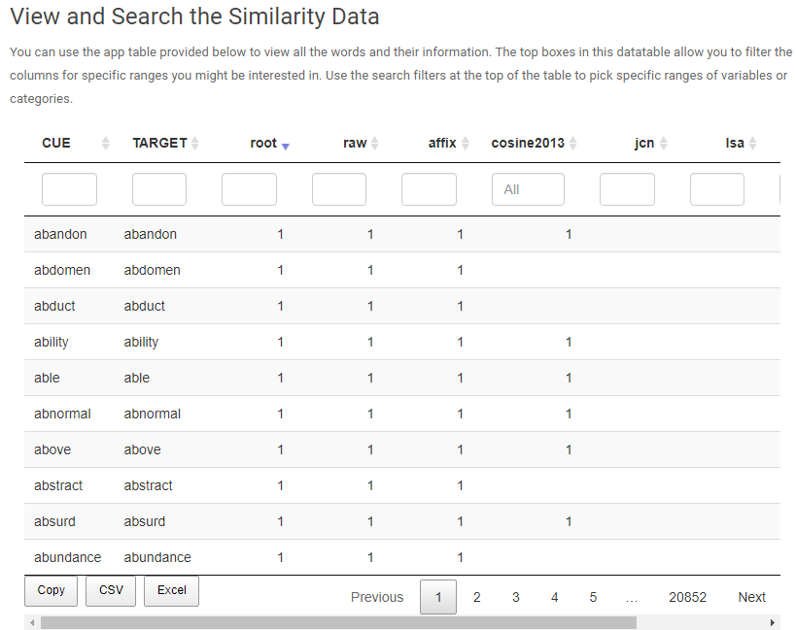

1. In the following example I typed **cat** into the **Cue** box and got the list below. In addition, I sorted in descending values from the **root** column, this provides a list of words with a higher level of agreement with the cue word. You can set a range of parameters. The root values range from 0 (not related) to 1 (highly related) and as such we can treat the root value in a similar fashion to a correlation r value
2. As you can see cat and dog are highly related at .69 and while cat and squirrel also have a strong relationship, moving to the next page might bring up other semantically related words that you might want to use (e.g. cat and cougar) even though the relationship is smaller, they are related by virtue of being animals/mammals/felines. This is where having an acceptable range to use for the root value will help you make the best judgements about your word pairs

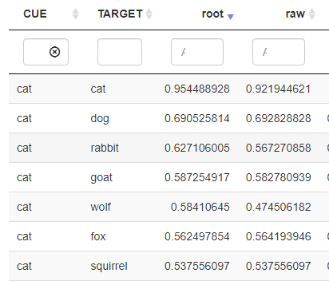

1. You can download these outputs to an Excel file (recommended), but it is certainly in your interests to record the cue/word and the root value for each pair of real words that you generate